Autumn 02 | Assignment

Video control
1. Using the UI components, make a video control located next to the video to be played.
2. Using actionscript, buttons and/or movie clips make your very own video control.

Who’ done it
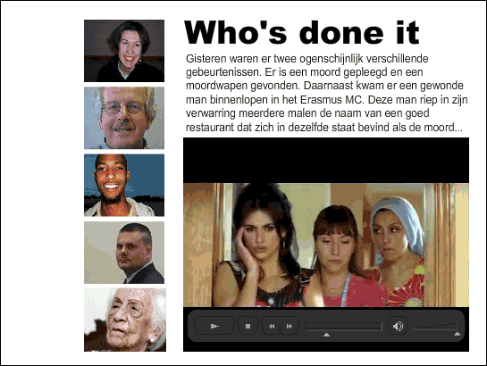
Yesterday two apparently different things happened. There was a murder and the murder weapon was found. And an injured man walked into the Erasmus medical centre. Utterly confused the man mentioned the name of a good restaurant several times, which was located in the same street where the murder was committed …
Make an application in which you can choose several videos. Stills of this video are the navigation. With a click on a still the film running is replaced by the film of your choice. In the above example everything is put in the context of a "Who's done it" detective story. Choose your own context and make a beautiful application.
Author: Barend Hendriks
Season: Autumn
Lesson number: 02
Date: 05-09-2006
Type of lesson: MME

